**The Nesting Ecology of Diamondback Terrapins (*Malaclemys terrapin*) in Barnegat Bay, New Jersey**

By Alyssa Frediani

Submitted in partial completion of a Bachelor of Science Degree in Environmental Studies, University of Vermont

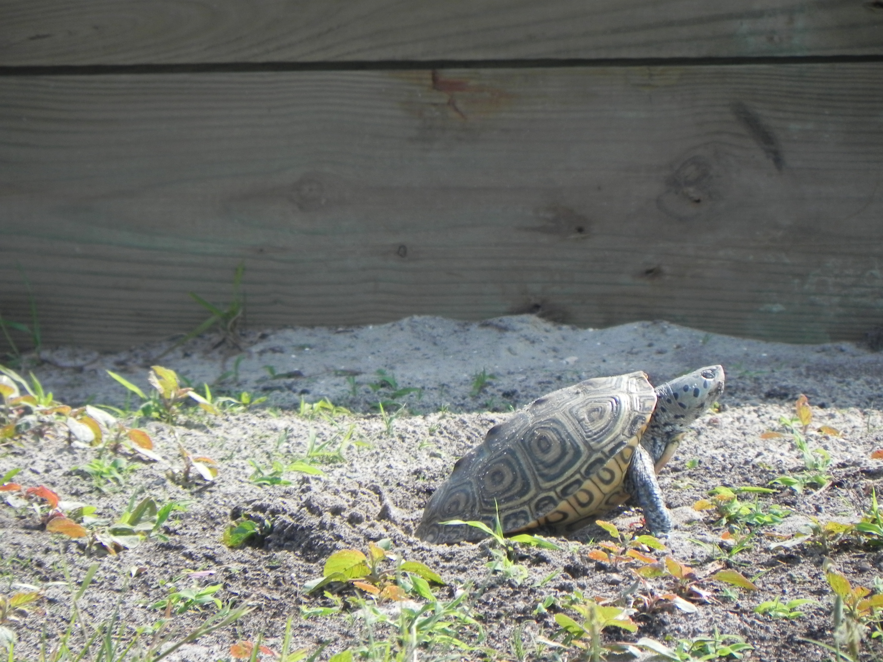

**ABSTRACT**

Diamondback terrapins (*Malaclemys terrapin*) are endemic to the Atlantic and Gulf coasts of the United States. Marshes and shorelines are critical to terrapins, and these habitats are being destroyed on a large scale by human development. In Barnegat Bay, New Jersey, where this project took place, over 45% of the shoreline has been walled or bulkheaded, and only 29% of the Barnegat Bay shoreline is in its natural state. As a result of this terrapins have been seeking alternative nesting locations, which may not be as suitable as historic sites were. This research focused on the nesting ecology of diamondback terrapins on North Sedge Island in Barnegat Bay in order to determine whether there was any correlation between female size and clutch size, mass or nest depth. This will provide better insight in the nesting ecology of terrapins at Barnegat bay, which may help to improve the population status of terrapins throughout the area. The study was completed from May to August 2011. We found that there was a correlation between female terrapin plastron length and clutch size as well as female plastron length and clutch mass. There was a very low correlation between female terrapin plastron length and nest depth as well as the depth of the first egg.

**ACKNOWLEDGEMENTS**

I would like to thank John Wnek for allowing me to be a part of this study and for providing me with the training and tools necessary to complete the project. I would also like to thank Jules Winters and Jackie and Tony Raneiro for their help in completing this project.

**Table of Contents**

Introduction………………………………………………………………………………………………………………..….5

Literature Review…………………………………………………………………………………………………………...6

Methods……………………………………………………………………………………………………………………….11

Results and Discussion…….……………………………………………………………………………………………14

Conclusion……………………………………………………………………………………………………………………17

Works Cited………………………………………………………………………………………………………………….19

Appendix A: Tables and Figures………………………………………………………………………………….…21

Appendix B: Pictures…………………………………………………………………………………………………….28

**INTRODUCTION**

The diamondback terrapin (*Malaclemys terrapin*) is a turtle species that is endemic to brackish water on the eastern coast of the United States. There are seven recognized subspecies of terrapin and this study focused on the northern diamondback terrapin (*Malaclemys terrapin terrapin*). The main threat that diamondback terrapins face are humans (Hart and Lee 2006). Their numbers have been declining for several years across their range as a result of loss of nesting habitat through human development on nesting beaches, in combination with high site fidelity exhibited by females (Gibbons et al. 2001). Several studies have been conducted which pertain to the general ecology of diamondback terrapins, but there are few studies that address nesting ecology.

The study took place on North Sedge Island, in Barnegat Bay, in southern New Jersey. Barnegat Bay is home to a wide variety of organisms, however every summer the human population of the area increases drastically as tourists flock to the ocean for vacation. This directly coincides with the terrapins’ nesting season. There are a variety of ways that the human traffic can affect the terrapins, which other studies have looked at. In order to really understand how humans are impacting the terrapins, more research on the general ecology of the species must be done. This study will look more closely at how female plastron length is correlated with nest depth, clutch size and clutch mass. This will help us to better understand the factors that affect their nesting processes. Terrapins are considered a species of special concern in the state of New Jersey because not much is known about their actual population numbers. By understanding more about their nesting ecology, we can better understand this species and hopefully increase the success of the species in this particular area.

**LITERATURE REVIEW**

The diamondback terrapin (*Malaclemys terrapin*) is a small, estuarine turtle found from coastal Massachusetts to Florida and around the Gulf coast (Coker 1906). The International Union for the Conservation of Nature lists the diamondback terrapin as near threatened in its range (Baillie and Groombridge 1996). There are seven recognized subspecies of diamondback terrapins, three of which are considered endemic to their regions (Butler et al. 2004). Only two of these subspecies are found outside of Florida; the northern diamondback terrapin, which ranges from Cape Cod, Massachusetts to Cape Hatteras, North Carolina, and the Texas diamondback terrapin, which is found from Louisiana to Corpus Christi Bay, Texas (Butler et al. 2004). Terrapins can be distinguished from other turtles by their distinctive shell markings and body coloring. Female northern diamondback terrapins have an average carapace length of 160.2 mm and male northern diamondback terrapins have an average carapace length of 120.5 mm (Gibbons et al. 2001).

Terrapins spend the majority of their lives in brackish waters such as tidal creeks, coastal salt marshes, estuaries and lagoons. Studies indicate that tides can influence how terrapins utilize their habitat; during high tides females have been seen entering salt marshes to forage and then moving to tidal creeks during the ebb tide (Butler et al 2003). Diamondback terrapins have a particular affinity for mollusks and crustaceans, such as blue mussels, horse mussels, fiddler and mud crabs, all of which can be found in the marshes (Hart and Lee 2006). In addition, there is a strong correlation between height of the tidal water and the number of females laying eggs (Burger 1975). During the winter, terrapins bury themselves in muddy creek bottoms, either in groups or individually, and brumate, the reptile equivalent of hibernation, however little is known of the specifics of this process (Hart and Lee 2006, Ultsch 2006).

Female northern diamondback terrapins reach sexual maturity later than males do, at around six years of age (Wnek 2010). Northern diamondback terrapins can live up to forty years (Butler et al 2004). Courtship for the terrapins occurs during May and June. The female will float near the surface while a male terrapin approaches from the rear and nudges her cloacal region with his snout and if she is receptive copulation occurs. Females will come ashore from late May through July to lay their eggs. Nesting terrapins prefer sandy areas for their nests, such as dunes, islands, dike roads or sandy marsh edges, which often puts them in contact with humans (Burger and Montevecchi 1975). They tend to nest in areas with 25-50% vegetative cover, as more open areas can affect the temperature of the nest which in turn influences the sex of the hatchlings (Palmer and Cordes 1998).

Predation plays a large role in shaping the diamondback terrapin population. Both eggs and hatchlings can be preyed upon by raccoons (*Procyon lotor*), crows (*Corvus brachyrhynchos*), laughing gulls (*Larus atricilia*), red fox (*Vulpes vulpes*), skunks (*Mephitis mephitis*) and herring gulls (*Larus delawarensis*) (Feinberg and Burke 2003). Plant roots, fungal infections, and maggots can also damage nests and eggs (Feinberg and Burke 2003). Crows and other mammalian predators could dig up an already covered nest. Gulls will leave the covered nest alone, and are only a threat during the laying period (Burger 1977). In addition, nests that are in areas of lowest nest density tend to have the lowest rates of predation (Burger 1977). There seems to be a correlation between nesting time and tides; female terrapins tend to nest during high tide when distance from the nest to water levels would be smallest and exposure to terrestrial predators is limited (Butler et al 2003, Burger 1975).

When a female terrapin finds suitable nesting habitat she will begin moving soil with her front limbs. Once the hole is a satisfactory size, she will position herself over the nest, finish digging with her rear limbs, and deposit her eggs in the flask-shaped nest. The northern subspecies has highest mean clutch size, at 12.9 in Maryland, 12.9 in New Jersey and 15.8 eggs in Rhode Island (Butler et al 2004, Wnek 2010). The depth to the top egg deposited is usually between 94.1-106.5 mm and range to the bottom of the egg chamber is usually 139.9-165.0 mm. In New Jersey estimated nest density is 157.1/ha. The clutch size varies from two to nineteen eggs (Wnek 2010). If the female is approached while she is searching for a nest she will run for cover, or back to the water, and if she is approached while laying her eggs she will abandon the nest if she has only laid a few eggs (Burger 1977).

When the terrapin first deposits its eggs in the nest, they are somewhat translucent and pink, but within twenty-four hours the embryo starts forming and the shell turns opaque and white. The mean egg sizes fall within the following measurements: lengths between 31.1-39.0mm, widths between 19.7-23.9mm, mass 7.7-12.4g. Eggs typically hatch from early August through mid-October in the northern part of the range. The time at which the eggs hatch depends on the temperature and moisture content. Eggs will successfully hatch between 18°-34°C; any temperatures higher than 34°C are lethal to developing embryos (Jeyasuria and Place 1997). Terrapins, like most turtles, also exhibit temperature-dependent sex ratios. One study showed that females choose their nest sites in order to produce the different sex ratios (Roosenburg 1996). A nest temperature of 29°C is considered the pivotal temperature where a 50/50 male to female ratio occurs. Temperatures above this produce more females and below produce more males (Jeyasuria and Place 1997).

Northern diamondback terrapin hatchlings have a mean carapace length of 27.5mm and a mean mass of 6.8g. The hatchlings in the southern part of the range are generally a bit larger than those in the northern part of the range, which is consistent with the fact that their eggs are usually larger. Hatchlings have a tendency to avoid the open water and instead seek refuge in salt marshes or vegetation (Butler et al 2004). Hatchlings emerge over the course of one or four days (Burger 1976).

One severe threat that terrapins currently face is nest predation at the egg stage; predation of the northern terrapin ranges from 24-88% in New Jersey (Burger 1977). The two main problems faced by hatchlings are successful emergence from the nest and completing a successful trip to the nearest cove. Raccoons generally prey upon the hatchlings that do not emerge from the nests (Burger 1976).

The most pressing issue that the diamondback terrapin faces is loss of nesting habitat. Coastal areas are becoming increasingly more and more developed, with people altering prime terrapin nesting habitat. The increase in off-road vehicles being permitted on the beach also jeopardizes terrapin nesting areas, as well as road fragmentation, which can break up dune communities (Hart and Lee 2006). Road casualties are becoming more common as roads break up the expanse of land from the bay to the ocean, especially within the study site for this project, Island Beach State Park. In addition, terrapins can drown if caught accidentally in eel pots or commercial-style crab pots and can also become entangled in fishing gear. Steps are being taken to avoid some of these problems, for example placing turtle excluders on blue crab traps (Hart and Lee 2006).

Turtles worldwide, including diamondback terrapins, are increasinlgy subject to human disturbances given certain characteristics of their development, such as delayed sexual maturity, little parental care and terrestrial nesting activity (Hart and Lee 2006). Terrapins need to have high adult and juvenile survival rates in order to maintain a steady population. They take a relatively long time to reach maturity and face high rates of juvenile mortality, as a result take a significant amount of time to recover from population declines. Attempting to mitigate certain causes of death at these stages in life will be essential to ensuring the survival of diamondback terrapins in the future (Hart and Lee 2006).

**METHODS**

**Study Site**

The study took place on North Sedge Island, Barnegat Bay, New Jersey. The island lies between mainland New Jersey and Island Beach State Park, about three miles from the mainland of New Jersey and a little over a mile from the park (Figure 1). The waters in this area are part of the Sedge Island Marine Conservation Zone and are only open to recreational boaters. For the most part motorized vehicles are not found in the area; the majority of boat traffic is from kayakers. Groups sponsored by New Jersey Fish and Wildlife make overnight trips to the island. There is a bunkhouse, a boathouse and a residential home on the island (Figure 2). The island is only inhabited during the summer months when the caretakers are present on the island and education groups are making trips. There is a dock in front of the house and a dock in front of the boathouse. Pontoon boats are used to travel between the island and Island Beach State Park. The remainder of the island is salt marsh and not subject to human traffic.

The hatchery is located on the west lawn of the island, on an area where terrapins naturally come up to nest (Figure 3). There is some bulkheading in this area, however it ends at a small sandy beach where terrapins can access the land (Access 1, Figure 3). There is another open area on the water where terrapins can access their nesting grounds (Access 2, Figure 3). On the other side of the bunkhouse there is a small beach area that is used as a kayak launch, where terrapins also come up to nest (Access 4, Figure 3). The terrapins also utilize the lawn near the Raniero’s house to nest by using a small sandy area to access the lawn from the water (Access 3, Figure 3). For the most part the island is undisturbed by motorized watercraft and people. The groups that come out are educated about the island and its wildlife and work to minimize their impacts on the land while they are there.

**Monitoring Methods**

This project took place from late May until the end of August during the summer of 2011. We examined the female size in relation to their nest depth (cm), clutch size, and clutch mass (g). In order to do this we monitored the site on a daily basis for females that were laying eggs and then analyzed their clutches. Egg masses, egg lengths and egg widths were measured and the nests were monitored until the eggs hatched.

The site was monitored for females laying eggs, females searching for a nesting site or previously laid nests, daily. All nesting female diamondback terrapins that were captured were marked using a notched shell system and passive integrate transponder (PIT) tags, if they did not already have them. The females’ carapace length (mm), plastron length (mm), carapace width (mm), carapace height (mm) and mass (g) were measured for each female. The nests were carefully dug up and the masses of all of the eggs were measured. We made sure not to turn or rotate the eggs as this could have damaged the developing embryo. Digital calipers were used to measure egg length (mm) and width (cm)of each egg. Depths (cm) of each nest were measured at the top and bottom of the nest cavity.

Eggs were placed in dimpled foam carrying trays within a plastic “shoebox” container and the nests were transplanted in one of two secure nesting areas. Secure areas had wire fencing around them, and each nest received a predator exclosure cage (0.6cm mesh), which was put into the ground at a depth of 20cm so mammalian predators could not dig them up. Nest depths were dug in the nesting area according to the measurements that were taken on the nests dug by the female terrapin. Eggs were placed in the new nest in the order that they were taken out of the original nest dug by the female terrapin.

The nesting area was monitored from late May through August until the eggs produced hatchlings. Nests were monitored daily after approximately sixty days, to ensure that hatchlings were removed from the nest as close to emergence as possible. Nests were monitored until all hatchlings that could have emerged did.

**Statistical Analysis**

Data were pooled at the end of the summer and analyzed to determine correlations. Pearson’s correlation coefficient was used to determine the relationship between female terrapin plastron length and depth of first egg, total nest depth, clutch size and clutch mass. Pearson’s correlation coefficient (r) shows the correlation between two variables on a -1 to 1, inclusive, scale. For females that laid more than one nest during the summer a Student’s T-test was used to determine whether there was a significant difference in masses of the first and second clutch. A Student’s t-test is a statistical test, which determines if there is any difference between two given means. Pearson’s correlation coefficient was also used to determine whether there was any correlation between female plastron length and the number of clutches laid during the summer. Finally, the data was compared with the data collected during 2008 and 2009 to determine if there was a correlation between female carapace length and clutch size or clutch mass across all three years. Data for 2010 was not available.

**RESULTS AND DISCUSSION**

Data was collected for forty-eight nests from May to July 2011. The data that follows in this section shows the correlation coefficients for each variable measured, nest depth, clutch size and clutch mass, as well as the results of the t-tests that were conducted. Pearson’s correlation coefficient (r) ranges from -1 to 1, inclusive and shows a strong correlation when r=1. A negative correlation would give a value of r=-1 and no correlation would be when r=0. The t-test was conducted with an alpha value of 0.05..

Pearson’s correlation coefficient was used to determine whether there was any correlation between female terrapin plastron length and depth of first egg, nest depth, clutch size, clutch mass. Pearson’s correlation coefficient comparing female plastron length with the depth of the first egg gave an r value of 0.226. The correlation coefficient comparing plastron length and total nest depth gave an r value of 0.096. The correlation coefficient for plastron length and clutch size gave an r value of 0.586 and the coefficient comparing female plastron length and total clutch mass was r= 0.637 (Table 1, Figures 4-8).

The Student’s T-test was used to determine whether there were any significant differences between the mean clutch size for females that laid multiple nests and whether there were any significant differences between the clutch masses of females that laid two clutches. For the t-test n=8, as only eight females laid two or more nests. The t-test comparing mean clutch size for females that laid multiple clutches returned a p value of 0.509, which means there was no significant difference in the clutch sizes between first and second clutch. When the mean clutch masses were examined for differences the p-value that was returned was 0.518, which means we were once again unable to reject the null hypothesis; there was no significant difference between the mean clutch masses (Table 2).

Pearson’s correlation coefficient was used again to determine whether there was any correlation between female terrapin plastron length and the number of clutches a female produces. The Pearson’s correlation coefficient comparing plastron length with the number of clutches was 0.190. The correlation between female terrapin carapace length and clutch size for 2008, 2009 and 2011; the correlation coefficient was 0.431. Female terrapin carapace length was compared to total clutch mass across all three years and the correlation coefficient was 0.544. This shows a weaker correlation, based on Pearson’s correlation coefficient, than the data from only 2011 did. The correlation coefficient for carapace length versus clutch size for 2011 was 0.554 and for carapace length versus clutch mass it was 0.591 (Table 3, Figures 9-12).

The correlation coefficients for female plastron length versus depth of first egg and total nest depth were quite low (0.226 and 0.096 respectively) which suggest that there is not a very strong correlation between the factors. This could be due to the small sample size (N=48 nests). The depth of the nest could depend mostly on the substrate. Diamondback terrapins rely on temperature to establish their sex ratio and that could limit the depth of the nest; too deep and the ground may be too cool. A larger female may not dig a deeper nest because that may not benefit her eggs.

The correlation coefficient for female plastron length versus clutch size was relatively high (0.586) which is indicative of turtles as the female carries the eggs in her body cavity and the size of which is related to clutch size. The mean clutch size at Sedge Island was 13 eggs. It could be that even for a larger female the metabolic requirements for producing a clutch that is significantly larger than 13 may be too great. It does seem to hold true however that smaller females are not producing as large of a clutch as larger females are. This could be because it may be their first year reproducing and therefore she has not reached her full size. It could also be a result of a smaller body cavity not being able to hold a large clutch of eggs.

The correlation coefficient for female plastron length versus total clutch mass was relatively high as well (0.637) suggesting there is a stronger relationship between clutch mass and body size than the clutch size and body size. Female terrapins may only be able to carry a certain percentage of their body weight and this could limit the clutch size more than the actual number of eggs may limit it. This would also help to explain the stronger correlation seen here. The correlations for carapace length and clutch size and carapace length and clutch mass were stronger for the 2011 data than they were for the pooled data from 2008, 2009 and 2011. This could have been due to sampling area as the difference between the two is not significant.

Student T-tests that were performed to compare the mean clutch sizes and clutch masses for females that nested more than once were both not significant (p-values of 0.509 and 0.518 respectively). This was most likely to due to the small sample size (N= 8). This is not an adequate sample size to draw valid conclusions from. There was a greater difference in the mean mass between the two nestings; the second nesting seemed to have a slightly higher mean mass, however it was not a significant difference. Further samples would be needed in order to determine if there is any significant difference between first and second nestings in the terrapins.

**CONCLUSION**

Diamondback terrapins are considered a species of special concern because not much is known about their life histories. Any data that can be gathered about the terrapin is useful because it brings researchers one-step closer to ensuring the survival of this unique animal. This study examined certain characteristics of the Northern Diamondback terrapin’s physiology in order to see how these relate to the nesting ecology of this species. These conclusions can help with management practices for the diamondback terrapin in southern New Jersey.

The results showed that there was not a strong correlation between female plastron length and depth of either the first egg or the total depth of the nest (r= 0.226 and r=0,096 respectively). This could be due to environmental factors. The type of soil substrate would affect the temperature of the ground, which in turn impacts the sex of the hatchlings. Vegetation cover will also affect the temperature of the ground. Given all of these things it is possible that females are digging their nests, not based on their body size, but on environmental conditions that are going to affect the temperature of the nest. This has important ramifications in southern New Jersey as a lot of the area outside of North Sedge Island where diamondback terrapins are nesting is being impacted heavily by development. Roads and other infrastructure could influence ground temperature and construction will likely influence the substrate that is found in nesting areas. This must be taken into consideration when managing for the terrapin.

The results showed a rather strong correlation between female terrapin body size and clutch size (r=0.586) and there was an even stronger correlation between female terrapin plastron length and clutch mass (r=0.637). We can conclude from this that larger females are producing larger clutches. This means that to some extent larger females are going to be important in the success of the population of terrapins. Historically terrapins were hunted for food, but this practice was ended as numbers started declining. In the future if it was decided that terrapin numbers were stable enough for harvesting to begin again this could have an affect on body size. Oftentimes humans harvest for the largest individuals, which can often drive the population to become physically smaller and smaller. This could have a compounding effect on the actual population numbers, as smaller females will not be able to produce as large of a clutch as larger females can.

The data comparing differences in mean clutch sizes for females was inconclusive. This was most likely due to the small sample size of only 8 females. Further studies would need to be done in order to determine if there is any significant difference between the first and second nestings. It would also be useful to understand what drives females to nest multiple times in one season. These will have important management implications.

In conclusion, understanding the physiology and nesting ecology of the diamondback terrapin will ensure that in the future management strategies can maximize the terrapin population.

Works Cited

Baillie, J. and Groombridge, B. 1996. *1996 IUCN red list of threatened animals.* International Union for Conservation of Nature, Gland, Switzerland.

Brooks, W.K. 1893. Fish and fisheries: the diamond-back terrapin. Maryland: its resources, industries and institutions. John Hopkins University 261-263.

Burger, J. 1975. Nest site selection in terrapin Malaclemys terrapin. Copiera 1975: 113-119.

Burger, J. 1976. Behavior of hatchling diamondback terrapins in the field. Copiera 1976: 742-748.

Burger, J. 1977. Determinants of hatchling success in the diamondback terrapin, *Malaclemys terrapin*. American Midland Naturalist 97:444-464.

Butler, J.A., Broadhurst, C., Green, M and Mullin, Z. 2004. Nesting, nest predation and hatchling emergence of the Carolina Diamondback terrapin, *Malaclemys terrapin centrata*, in northeastern Florida. *American Midland Naturalist* 152 (1): 145-155

Feinberg, J.A., & Burke, R.L. 2003. Nesting ecology and predation of diamondback terrapins, malaclemys terrapin, at gateway national recreation area, new york . *Journal of Herpetology*, *37*(3): 517-527.

Gibbons, J.W., Lovich, J.E., Tucker, A.D. et al. 2001. Demographic and ecological factors affecting conservation and management of the diamondback terrapin (Malaclemys terrapin) in South Carolina. Chelonian Conservation and Biology 4: 66-74.

Hart, K.M. and Lee, D.S. 2006. The diamondback terrapin: the biology, ecology, cultural history and conservation status of an obligate estuarine turtle. Studies in Avian Biology 32: 206-213.

Jeyasuria, P. and Place, A.R. 1997. Temperature-dependent aromatase expression in developing diamondback terrapin (*Malayclemys terrapins*) embryos. The Journal of Steroid Biochemistry and Molecular Biology 61: 415-425.

Montevecchi, W.A. and Burger, J. 1975. Aspects of the reproductive biology of the northern diamondback terrapin Malaclemys terrapin terrapin. American Midland Naturalist 94:166-178.

Roosenburg, W. M. 1996. Maternal condition and nest site choice: an alternative for the maintenance of environmental sex determination?. Amer. Zool. 36: 157-168.

Ultsch, G.R. 2006. The ecology of overwintering among turtles: where turtles overwinter and its consequences. Biology Review 1-29.

Wnek, J. 2010. Anthropogenic impacts on the reproductive ecology of the diamondback terrapin, *Malaclemys terrapin.* 1-151.

**APPENDIX A: TABLES AND FIGURES**

**Table 1.** The Pearson’s r correlation coefficient values for female plastron length and depth of first egg, total nest depth, clutch size, total clutch mass and number of clutches. There is a relatively strong correlation between plastron length and clutch size and clutch mass.

|  |  |
| --- | --- |
|  | Pearson's r Value |
| Plastron Length v .Depth of first egg | 0.226 |
| Plastron Length v. Total Nest Depth | 0.096 |
| Plastron Length v. Clutch Size | 0.586 |
| Plastron Length v. Total Clutch Mass | 0.637 |
| Plastron Length v. Number of Clutches | 0.190 |

**Table 2**. The averages, variances and p-values for the t-test comparing the differences in mean clutch size and clutch mass between first and second clutches. There was no significant difference for either when α=0.05.

|  |  |  |  |  |
| --- | --- | --- | --- | --- |
|  | **Clutch Size 1** | **Clutch Size 2** | **Clutch Mass 1** | **Clutch Mass 2** |
| Average | 14.125 | 14.875 | 115.675 | 120.95 |
| Variance | 2.411 | 7.268 | 92.594 | 403.98 |
| T-test P-value | 0.509 |  | 0.518 |  |

**Table 3**. The Pearson’s correlation coefficient values for the pooled data and 2011 data for female carapace length versus clutch size and clutch mass.

|  |  |  |
| --- | --- | --- |
|  | Pooled Pearson's r | 2011 Pearson's r |
| Carapace Length v. Clutch Size | 0.431 | 0.554 |
| Carapace Length v. Clutch Mass | 0.544 | 0.591 |

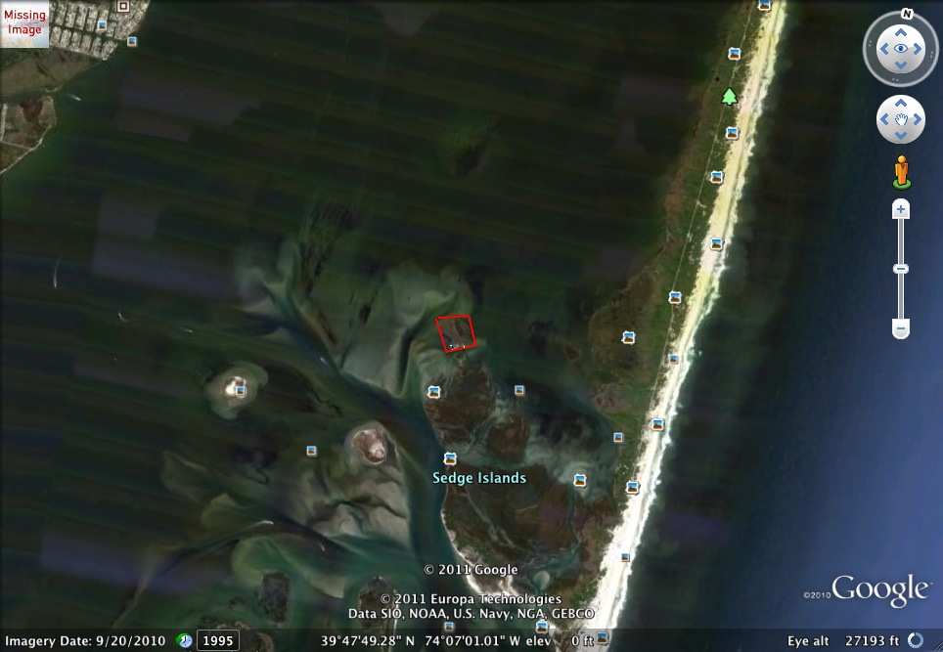

**Figure 1**. The red box encloses North Sedge Island, Barnegat Bay, New Jersey where the study took place (39°47’N, 74°7’W).

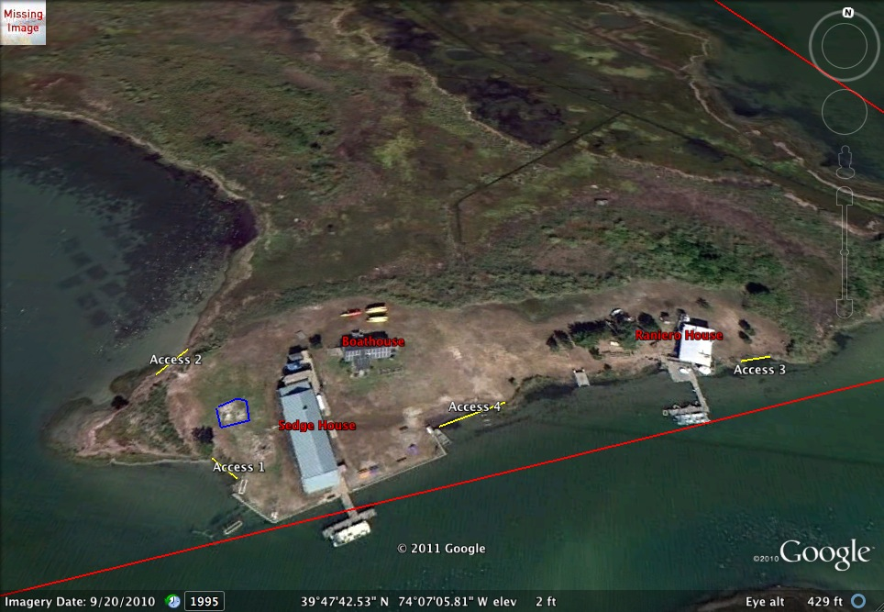

**Figure 2.** North Sedge Island depicting the hatchery in blue, nesting access areas in yellow and buildings in red (39°47’N, 74°7’W).

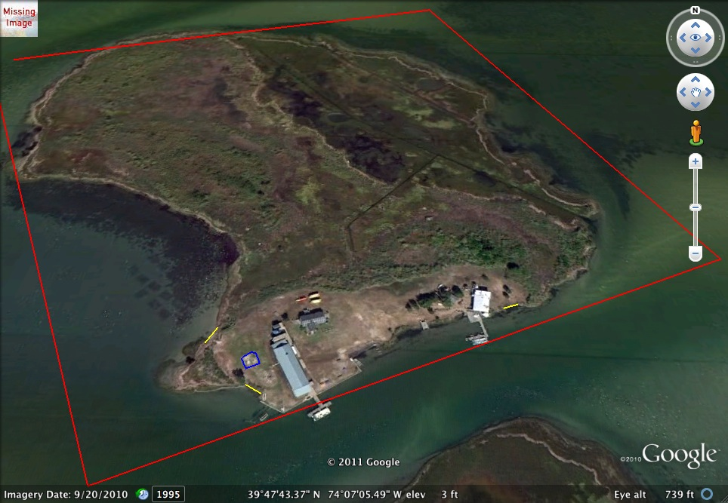

**Figure 3**. The red line encloses North Sedge Island, Barnegat Bay, New Jersey. The blue line encloses the hatchery on the island and the yellow lines represent the beach areas that we know the terrapins utilize to come up and nest (39°47’N, 74°7’W).

**Figure 4.** The Pearson’s correlation between female plastron length and the depth of the first egg with a linear trend line. There is not a strong correlation between the two (r=0.226).

**Figure 5**. The Pearson’s correlation between female plastron length and total nest depth with a linear trend line. There is not a strong correlation between the two variables (r=0.096)

**Figure 6.** The Pearson’s correlation between female plastron length and clutch size with a linear trendline. There is a relatively strong correlation between the two variables (r=0.586).

**Figure 7.** The Pearson’s correlation between female plastron length and the total clutch mass with a linear trend line. There is a relatively strong correlation between the two variables (r=0.637).

**Figure 8.** The Pearson’s correlation between plastron length and number of clutches a female produced during the nesting period. There was not a significant correlation between these two variables (r=0.190).

**Figure 9**. The Pearson’s correlation between female carapace length and clutch size for 2008, 2009 and 2011 pooled data. The correlation between these two variable was relatively strong (r= 0.431).

**Figure 10**. The Pearson’s correlation between female carapace length and clutch mass for 2008, 2009 and 2011 pooled data. The correlation between these two variables was relatively strong (r=0.544).

**Figure 11.** The Pearson’s correlation between female carapace length and clutch size for summer 2011. The correlation between these two variables was relatively strong (r=0.554).

**Figure 12**. The Pearson’s correlation between female carapace length and clutch mass for summer 2011 with a linear trend line. The correlation between these two variables was relatively strong (r=0.591).